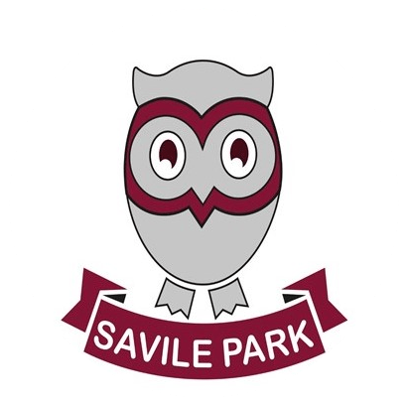
Music at Savile Park Primary School 2026- 2027

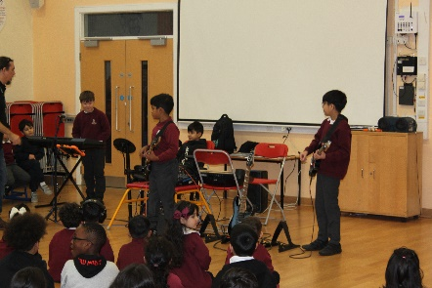
Celebrations from Autumn Term 2026…
- Year 2 Nativity ‘Little Stars Story’ -December
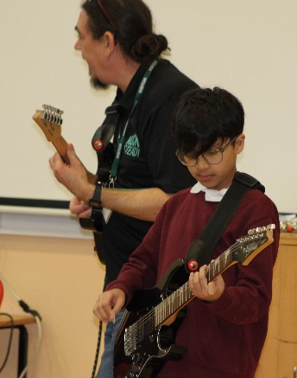
- Reception and Year 1’s Winter Festival- December
- Singing club/ Choir
- Rocksteady Christmas concert to parents
- Weekly Kapow and Charanga music lessons across school
- Staff CPD on Lau Lau training (rolled out in EYFS and KS1)

More to look forward to in Spring and Summer 2027…
- Year 2 African Drumming workshop
- School choir performances live across the year
- Weekly Kapow and Charanga music lessons across school
- Key Stage 2 Summer Festival
- Rocksteady Spring concert
- Voices Together- Year 4 performance at Victoria Theatre
- Rocksteady Summer concert
- Key Stage 2 creating and producing their own music- Yu Studio Charanga
- Visits to Calderdale Music- Old Court House

