As readers and authors we will be:

Be exploring the award winning children’s novel set in the near future – Floodland by Marcus Sedgwick. We will be linking the text to discussion reports and balanced arguments in our writing, as well as forming connections to our water study.
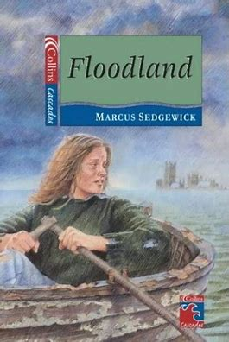

Autumn 1
Learning in Year 6
Topic: Water

Mr Kitchin Miss Makh Miss Rae

As sports stars we will be:
Developing ball skills, reaction/response and cognitive skills.
Taking part in attacking and defending games such as football.
Continuing to develop our fundamental movement skills including balance and balance with a ball.

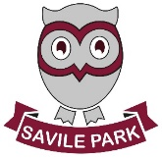

As scientists we will be:
Recapping our knowledge of electricity and circuits.
Investigating ways in which the brightness of a bulb or speed of a motor is changed.
Recognising and using conventional symbols for circuits.
Assessing our understanding of circuits.

As mathematicians we will be:
Be focusing on consolidating and extending the children’s learning regarding decimal numbers and place value.
Be moving onto consolidating the four calculation methods, if you require any information about how to support your child with this - please get in touch!
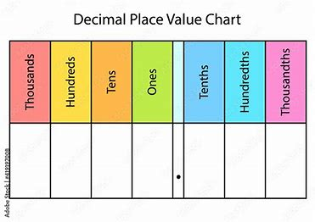

As members of our community we will be:
Be acting as role models for the rest of the children in the school. We will also have important school jobs including House Captains, School Ambassadors and Assembly Monitors, which are all imperative to the smooth running of the school day.
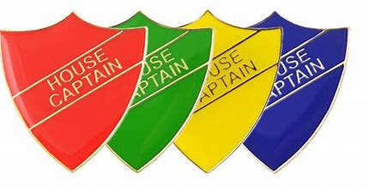

As musicians we will be:
Be following our school music scheme ‘ Charanga’ and listening to and appraising the song “Happy” by Pharell Williams. We will be using band instruments (glockenspiels and recorders) to create class ensembles based on our interpretations of being happy.


As geographers we will:

Be visiting Marsden to participate in field study activities, including mapping and river flow rate and depth tests, so that we can identify and recognise the physical features of a river at various stages on its journey. We will also study the effects that a river can have on its locality.
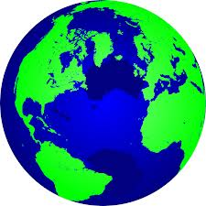

As artists and designers we will be:

We will be exploring craft and design through photo opportunity. We will be using photography and exploring how images can be changed through photomontage. We will create a final image with tonal differences that create a photo-realistic effect.

As linguists we will be:

Be focusing on initiating and sustaining conversations ensuring that we speak clearly and audibly with good pronunciation.

