Autumn 1
Learning in Year 5

Ancient Greece

As athletes we will be:
- developing social skills in PE

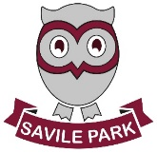
As readers and authors we will be:
- studying quest stories including
various myths from Ancient Greece
and Blodin the Beast by
Michael Morpurgo.

Following on from this,
we will be writing our
own setting descriptions,
creating our own mythical
beasts and writing a
quest myth.

As scientists we will be:
- looking at how forces affect everything around us
- learning about the effects of gravity, friction, air and water resistance
- exploring the ways in which pulleys and levers work
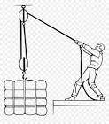

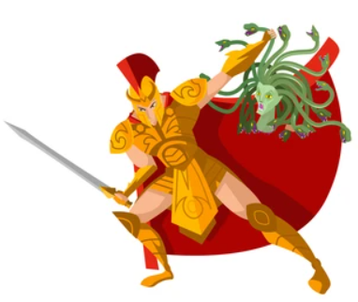

  Mr Mr Smith Mr Hartrick
As mathematicians we will be:
- reading, writing and ordering 6 digit numbers
- continuing to practise our written methods of calculation and mental strategies
- adding and subtracting numbers more than 4 digits and using the inverse to check
- learning how to round numbers
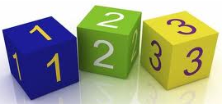

As musicians we will:
- explore music creation, recording and production using various digital tools

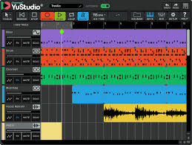

Homework
Homework in Year 5 is given out every Friday.
Reading books will also be changed three times a week (Mon, Wed, Fri) Please sign your child’s reading record 3 times a week to show that they have read at home.

As linguists we will be:
- learning about French
food, sports clothing
and the verb ‘avoir’.
We will also learn how
to express opinions

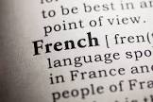
As historians we will be:
- travelling back in time to the Ancient Greek period
- learning how Greece became a powerful nation, the Olympics, Greek myths and gods and the legacy
- comparing different parts of Ancient Greece

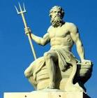

As members of our community we will be:
- learning about special journeys and places in our Religious Education lessons


As computing specialists we will
- Learning how to code



