As athletes we will:
- be following our Real PE scheme of learning
- be working on and building on our
fundamental movement skills
- be working on co-ordination and static balance
- be developing our personal skills
- be analysing our own learning and
independently challenging ourselves
- have swimming lessons at Sowerby
Bridge swimming pool every Tuesday.


Autumn 1
Learning in Year 4


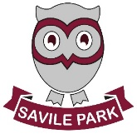
As readers and authors we will:
- be reading a variety of texts including those linked to our topic. We will be writing our own fictional stories and news articles surrounding our class text
- look at a variety of grammar features including those linked to our writing genre.


As mathematicians we will:
- be consolidating our knowledge of number bonds to 100 and identifying what each digit within a number represents including Roman Numerals.
- continue to practise our written methods of calculation and mental strategies. We will also be focussing on our times tables.

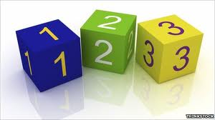

As linguists we will:
- be continuing our work on greetings from year 3 and learning how to use new phrases in different situations.

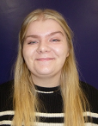

Miss McEwan Miss Ahmed Doctor Ovenden
As scientists we will:
- learn about animals including humans, including the simple functions of the digestive system in human beings.

As artists and designers, we will:
- design and make a pavilion that is strong and aesthetically pleasing.
- select and appropriate materials and techniques.
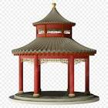

As musicians we will:
- learn to perform using our voices with increasing accuracy, fluency, control and expression.
- listen, with attention to detail and recall sounds.
- be appreciating and understanding music with a focus on Mama Mia.
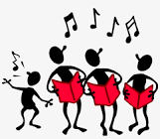

As historians and geographers we will:
- be looking at the key events that shaped modern day crime and punishment including the Romans, Saxons and Victorians. We will explore a number of historical items and use these to answer historical lines of enquiry to create a picture of events in time.
- use our developing knowledge of British, local and world history to identify connections, trends and contrasts over time.

