Autumn 1
Learning in Year 3
The Stone Age

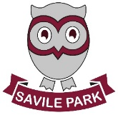
As athletes we will:
- Continue to use our Real PE skills learnt throughout KS1 and develop them further. Skills included: balance and coordination


As readers and authors we will:
- Read and write texts linked to our topic book Stone Age Boy.
- look at grammar features including expanded noun phrases, subordinating and coordinating conjunctions, statement, question and command sentences.
- Spellings focused on common exception words, homophones, near homophones and suffixes
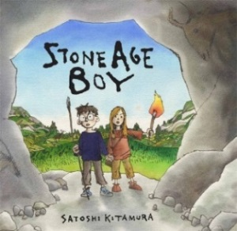


Miss Sykes Miss Lucas

As scientists we will:
- be looking at and categorising different types of rocks. We will study how different rocks are formed. Including the formation of fossils and excitingly be making our own dinosaur fossils!
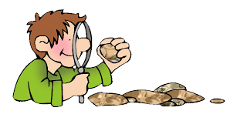

As mathematicians we will:
- recap our mathematical learning from year 2
- explore place value in 3 digit numbers
- Work on addition and subtraction number facts mentally
- Look at written methods for addition and subtraction
- solve problems linked to place value and mental addition and subtraction facts.

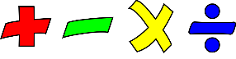

As members of our community we will:
Looking at what it is like to be Jewish and Jewish beliefs about God and looking at important festivals, stories and people of the Jewish faith.
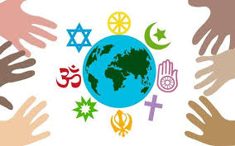

As artists and designers we will:
- be making some fantastic cave paintings
to fit in with our topic of the Stone Age
- looking at different types of
structures and designing and
making our own Stone Age shelters.

As linguists we will:
- begin to use French greetings in class and look at French numbers to 20
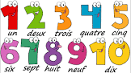

- Begin to look at pulse, rhythm and pitch as well as learning to count the beats in music
- Learn about our class musician ‘Ella Fitzgerald’ and Jazz music

As historians and geographers we will:
- do an in-depth study of the Stone Age, moving in to the bronze and iron ages looking at chronology
- look at their way of life including their homes, clothing, food and tools and compare to lives today
- look at the impact the time period has had on life today

As musicians we will:
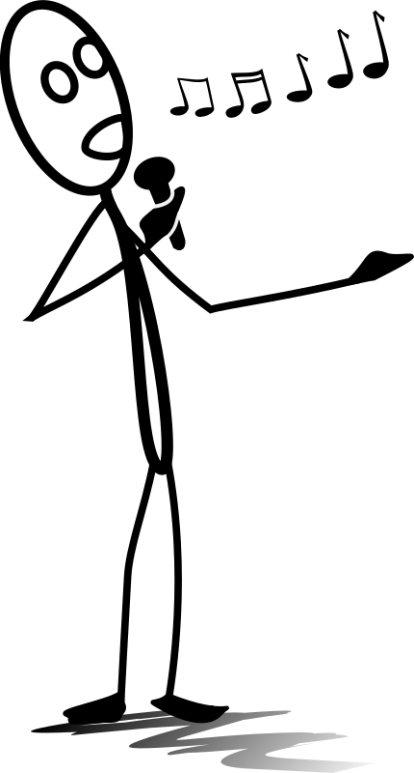

- Begin to look at pulse, rhythm and pitch as well as learning to count the beats in music
- Learn a song called ‘Let Your Spirit Fly’

