Autumn 1
Learning in Year 2
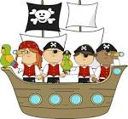
Topic: Pirates


Mrs Rhodes Mr Cole Mrs Collins Mrs Foster

As Sports Stars we will be:
- learn how to follow a simple dance routine based on a “pirate” dance
- practicing our footwork and static balances (on one leg)
- using breathing techniques and mindfulness activities


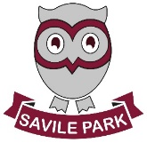
As Readers and Authors we will be:
- read pirate stories such as ‘Molly Rogers: Pirate Girl’ and looking at non-fictional texts on Blackbeard the pirate
- describe settings and characters in detail
- retell stories based on what we have read
- develop our use of adjectives and conjunctions
- write in simple sentences using correct punctuation
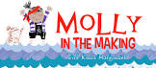

As Mathematicians we will be:
- learn about number and place value – ordering numbers 0 – 100
- add and subtract numbers to 100
- begin times table challenges – Y2 need to know x2, x5, x10
- compare numbers and use < > =
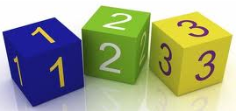

As Scientists we will be:
- Looking at living things and their habitats.
- Looking at the food chains of animals.
- Differentiating between living, non-living and dead.
- Understanding the basic needs of animals.

As Musicians we will be:
- learn about pitch and singing songs linked to changing the pitch of our voice
- listen to a variety of music by famous composers from classical to pop music.

As historians and developers we will:
- Researching famous pirates such as Blackbeard
- Creating fact files and looking at history of pirates
- Looking at maps and treasure maps, including creating our own
- Comparing famous pirates from the past
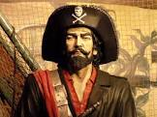

As Linguists we will be:
- Recap on phase 5 phonics letters and sounds
- Recap different ways of spelling the same sound. The sounds we will focus on will be: ee, ai, igh, oa, ch, c, g, ou, or, er,

As Designers we will be:
- Evaluating existing toys
- Designing a moving sea monster
- Creating a moving sea monster and evaluating our product
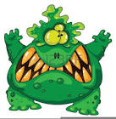

As members of our community we will be:
- in RE we learn about how different religious and non-religious groups and how they make good choices
- in PSHE, we will look at who we are in the world, our rights and responsibilities and rewards / consequences for our actions

