Autumn 1
Learning in Year 1
Topic: Our Super School

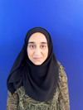
Miss Benson Mrs Hartley Miss Hussain

As scientists we will be:
- Observing and recording information about the four seasons.
- Observing and
describing weather
associated with the
seasons and how day
length varies.

As Readers and authors we will be:
- Practising to write in full sentences with full stops, capital letters and finger spaces
- Listening to stories; Superworm, Supertato and Zog.
- Writing daily dictated sentences linked to our growing phonics knowledge.
- Using role-play to explore, sequence and retell our favourite stories.
- Sequencing events in simple stories.

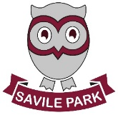

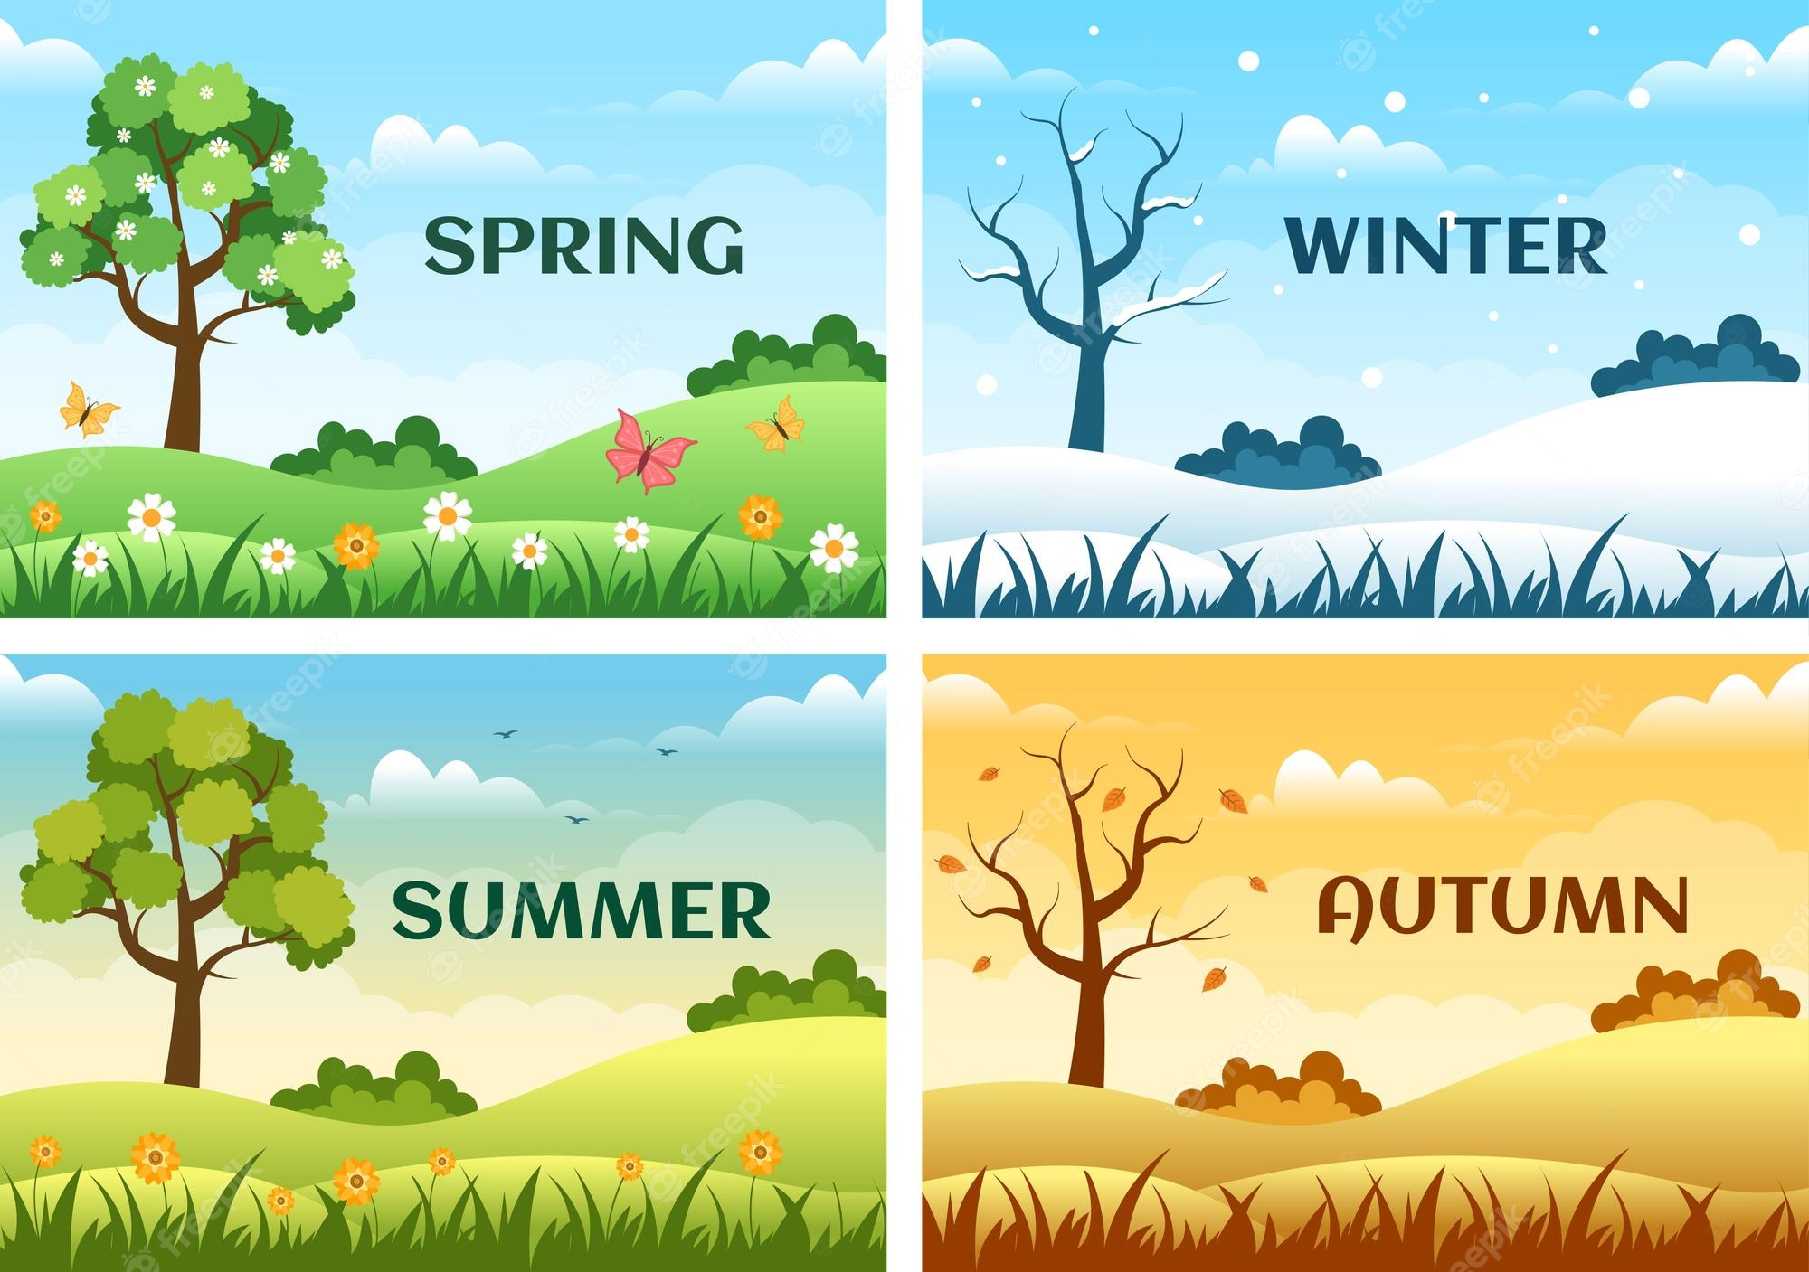

As artists and designers we will:
- Learn about the artist Andy Goldsworthy and how to create similar art work
- Use drawing, painting and sculpture work to create a range of observational art work linked with our local area and our topic.

As mathematicians we will be:
- Reading and writing numbers to 10 and beyond, comparing and ordering numbers and identifying 1 more and 1 less
- Counting forwards and backwards to 10.
- Recognising numbers in words.
- Adding and subtracting using objects.
- Beginning to recall and use number bonds to 10.
- Using number lines.
- Comparing numbers using the vocabulary Less than, greater than and equal to.

As athletes we will be:
- Following our REAL PE scheme to think about balance, coordination and different ways of moving.
- Using a variety of different sized
balls and movement techniques in
football.

As musicians we will be:
- Understanding what music is.
- Finding the beat in music.
- Improvising together.
- Learning to sing a song and performing it.

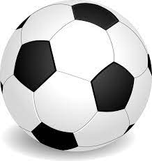

As linguists we will be:
- Reviewing all the phase 3 phonics graphemes (the letters) that have been taught in reception to ensure we know the correct phoneme (the sound).
- Continue to develop our phonic knowledge by moving on to phase 5.

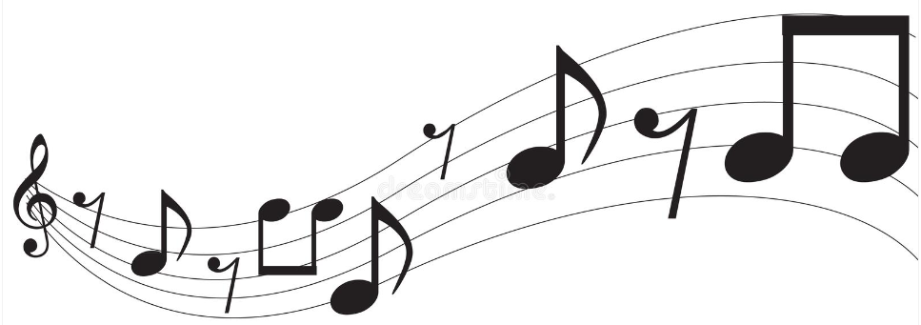

As members of the community we will be:
- Learning about which beliefs are important to us and other people in our local area.
- Learning about Harvest Festival and why it is important.
- Learning about new beginnings and relationships and how we can express feelings and emotions
- Exploring our local area and discuss how we can improve it.

In geography we will be:
- Use basic geographical vocabulary to refer to local and familiar features within our area.
- Look at picture maps of school and use these to help map our route to school
- Look at the routines of a school day and how this will change.
- Explore changes in living memory.

As computing specialists we will be:
- Learning about how to stay safe online.
- Exploring how to use laptops and ipads in the correct way.
- Using online maps to discover more about the local community.

