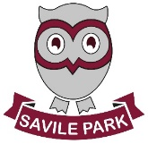
In Literacy we will be:
- learning the Phase 2 phonics sounds using Little Wandle
- playing listening games
- practising writing our names
- beginning to read and write simple words using the sounds we have learned
- verbally forming sentences and counting the number of words we need
- retelling stories and answering questions about what we have heard

Autumn 1

Learning in Reception
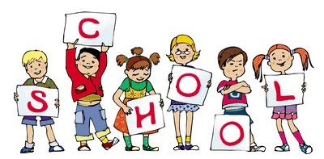Marvellous Me!

In Physical Development we will be:

- learning how to hold a pencil using a tripod grip
- practising dressing and undressing
by ourselves
- learning how to move safely and
show awareness of space and of others.
- learning how to safely use scissors.
- to our friends

In Maths we will be:

- learning about numbers and how to recognise numerals and their properties.
- using number rhymes and songs to learn the order and value of a number
- beginning to subitise numbers to 5
- learning how to sequence events
- introducing Numicon and building on it over the year

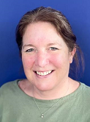

In Expressive Arts and Design we will be:
- learning how to use the creative areas and materials correctly – and learning how to tidy away too!
- painting self-portraits, portraits of our families and friends
- learning traditional rhymes, songs and moving to music
- using percussion instruments to perform

Mrs Dawson
Mrs Holmes
Reading books will be given out on a Friday, please practise at home with your grown ups. Phonics books with our new sounds in will be sent home on a Friday to be returned by the following Wednesday.

In PSED we will be:

- learning about the school core values
- learning our school rules
- getting to know our new friends and grown-ups in school
- learning about how we are unique
- talking about our families, interests and ourselves

In Understanding the World we will be:
- thinking about how we have changed since we were babies
- talking about past and present events in our own lives eg what we did over the summer, what we did at Nursery
- learning about keeping healthy and talk about how we have changed as we have grown
- using our senses to say what we can see, hear,
touch and feel

In Communication and Language, we will be:
- taking turns with speaking and listening
- talking about ourselves and asking questions to our friends
- talking about our experiences
- asking friends about their experiences

