As Mathematicians we will be:
Focusing on consolidating and extending the children’s learning to enable them to solve problems involving all aspects of the numeracy curriculum.
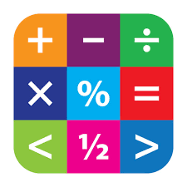

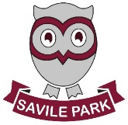
Summer 1
Learning in Year 6
Topic: Mayan Civilisations
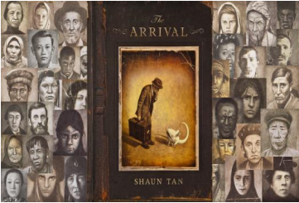

As Scientists we will be:

Our next unit in science will be light:
- we will be looking at how light is a type of energy
- we will discuss the different sources of light
- we will look at the different properties of light and compare opaque, transparent and translucent

As Readers and Authors we will be:
• looking at Shaun Tan book ‘The Arrival’
• writing poetry
• creating our own narrative around the book
maintaining an appropriate style, consciously
controlling the structure of sentences and
engaging the reader throughout.
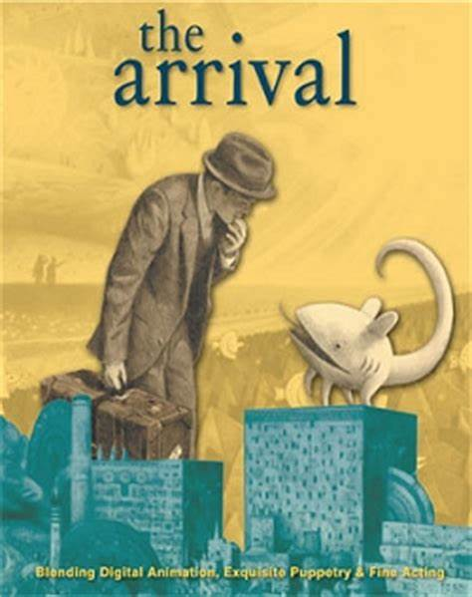

As Historians we will be:
Developing our historical and geographical knowledge through the study of the Mayans and the environment in which they formed their civilization. Focus areas will be developing historical enquiry into what the Mayans did for us including, astronomy, sculpture, architecture, medicine and the number system.

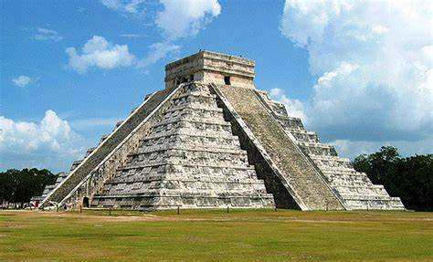

As Team Players we will:
Take part in striking and fielding games including cricket and rounders. We will be developing skills including catching, throwing, bowling and batting techniques.
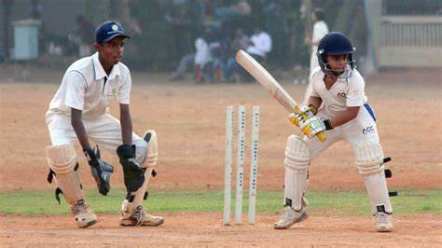

As Computer Technicians we will be:
Learning about and understanding the difference between the internet and the world wide web.

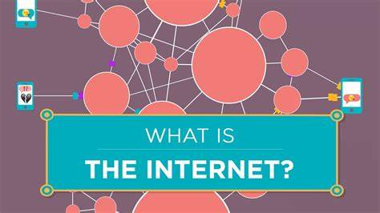

As Linguists we will be:
Providing well-structured descriptions, explanations and narratives for different purposes, including expressing feelings.



As artists we will be:
Exploring a unit called Make My Voice Heard. We will make relevant comparisons between different styles of art. We will respond to images and ideas through drawing, collecting a good range of imagery, adding annotated notes and sketches.

As Musicians we will be:
Exploring a unit called Farewell Tour, looking at songs and music that represent our class.

