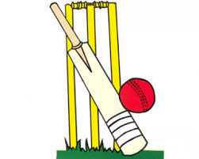
As readers and authors we will be:
- writing a recount and a letter
- continuing to practise using dialogue, commas and adventurous vocabulary
- using brackets, commas and dashes for parentheses
- working on comprehension skills
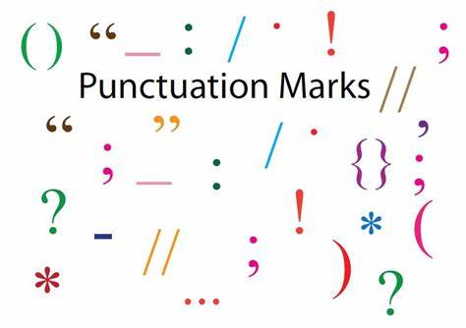

Summer 1
Learning in Year 5
Topic: Battle of Britain and the Blitz
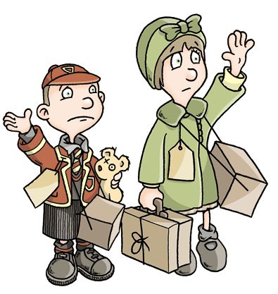

As athletes we will be:
- Playing rounders and
cricket
- Using creativity to
adapt games

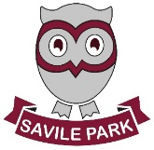

As technologists we will be:
- designing and making a cuddly toy for an evacuee and
- evaluating what we have made

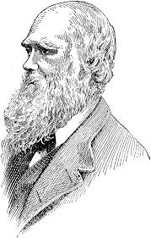
As scientists we will be:
Studying living things and their
habitats including:
- Animal life cycles
- Studying important scientists
- Reproduction in plants

As mathematicians we will be:
- identifying and describing 2D shapes including a range of quadrilaterals
- measuring angles with a protractor
- finding missing angles in triangles, straight lines and full turns
- converting different measures
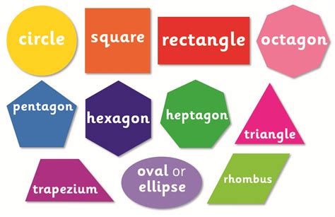

Homework
- Homework will be given as a homework grid with different activities to be completed before the end of the half term
- Reading books will be changed on
Monday and Fridays.
- Children are also welcome to choose books
from the classroom or library to take home to read
anytime.
Please could you help at home by revising times-tables and telling the time.

As musicians we will be:
- Learning about the songs from WW2.

As historians we will be:
- learning about Britain during World War II, including the Blitz, Battle of Britain, evacuation, air raids and rationing
- using and evaluating a range of primary and secondary sources as well as asking historically valid questions
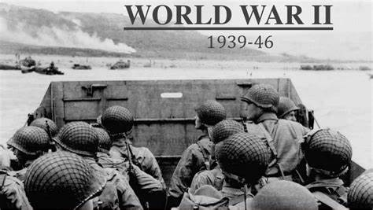

As computing specialists we will be:
- learning how to use spreadsheets and databases

As members of our community we will be:
- considering what codes for living different religious and non-religious groups have.

As linguists we will be:
- learning to count to 31 in French
- Learning the names of different animals
- Learning to talk about the weather 