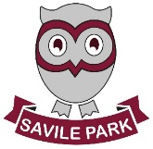
As Readers and Authors we will be:
- reading a variety of texts including those linked to our topic of Toffee Town
- analysing and writing newspaper
reports and descriptive non-chronological reports
- showing understanding of features
of different genres
- making references from a text and
justify answers with evidence
- studying the language used when writing for different audiences
- writing effectively for a range of purposes
- using inverted commas to convey direct speech

Summer 1
Learning in Year 4
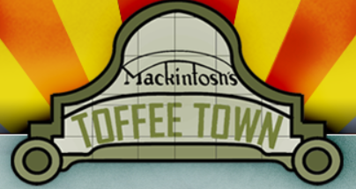

As Athletes we will be:
- learning a variety of fundamental movement skills, our reaction and response and floor work. We will also have the opportunity to practise our cricket skills
- continuing to develop our swimming skills – learning a range of strokes


As Mathematicians we will be:
- continue to work on our times tables up to 12x12
- looking at decimals, money and time

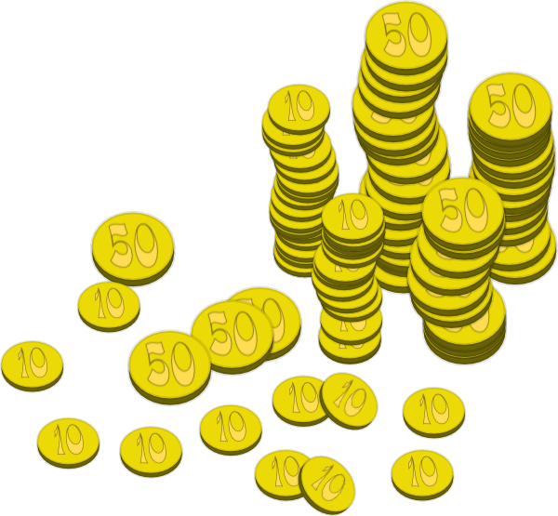

As Scientists we will be:
- developing our knowledge on electricity and electrical systems.
- We will be looking at a range of electrical sources, how to keep safe around electricity and discovering how circuits work.
- We will be looking at materials that conduct electricity.

As Members of our Community we will be:
- looking at our local area and inspirational people that have impacted where we live.
- in PSHE we will be exploring friendship and the relationships we have.

As Linguists we will be:
- continuing to increase our French vocabulary and extending our vocabulary into speaking in full sentences

As Historians and Geographers we will be:
    - looking at the history in our local area, Halifax
    - exploring the buildings and their uses in our local area
    - looking at changes in the industry that have happened over time in our local area
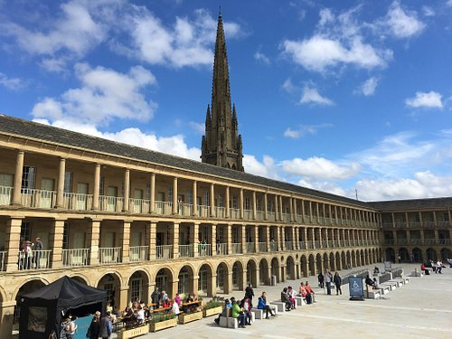

As Artists and Designers we will be:
- researching, designing, creating and evaluating our own design and technology project
- using a range of ingredients and equipment
to adapt a recipe



As Musicians we will be:
- learning what samba music is and that it is used in celebrations such as Carnival in Brazil.
- clapping on the off-beat (the and of each beat) and learning to play a syncopated rhythm.

