As Athletes we will be:
- Continuing to practise our throwing
and catching skills to incorporate these
into the games we play.
- Focusing on athletics, running, throwing and jumping skills.

Summer 1
Learning in Year 3
Topic : Yorkshire

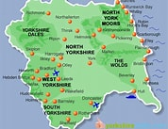

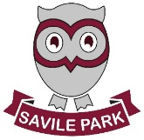
As Readers and Authors we will be:
- Focusing our reading and writing around the book ‘Tuesday’.
- Writing our own sequel to ‘Tuesday’
- Using a range of sentence openers, conjunctions (for example ‘until’,’ nor’ or ‘so’) and punctuation in their writing.
- Using speech, speech marks and remembering the rules of speech.


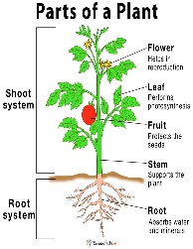

As Scientists we will be:
- Learning about plants.
- Identifying and describing the
functions of parts of plants.
- Exploring the way in which water
is transported in plants.
- Learning about pollination and seed dispersal.

As Mathematicians we will be:
- Fractions – Unit and non-unit fractions, adding and subtracting fractions.
- Money – adding, subtracting, converting and finding change.

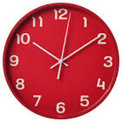

As Members of our Community we will be:
- Learning to understand different faiths and beliefs within our community.
- Express views through music, visual arts and dance.

As Geographers and Historians we will be:
- Using different maps to locate our school and other local places including our homes.
- Looking at map reading, creating maps, following routes and rural against urban areas.
- Learning the counties of the UK using internet mapping
- Learning the history of our county.
- Working on Microsoft PowerPoint.

As Linguists we will be:
- Continuing to develop our fluency in the language covered so far.
- Practicing the colours, animals and numbers learnt so far and using these in phrases.

As Musicians we will be:
- Thinking about how we can perform together and choreographing routines to fit the songs learnt, working towards a group performance.
- Performing a song in sign language.


As Artists and Designers we will be:
- Learning about our Famous Artist Rickard Kitson.
- Exploring botanical art inspired by our artist.
- Creating our own botanical art.
- Expanding our knowledge of colour by looking at how colour has been used by some of the great artists.
- Exploring a range of techniques to create botanical and landscape art.

In computing we will be:
- Exploring timers, repeat commands and the importance of nesting code through PurpleMash.
- Building up to using design documentation to code a program.


