As readers and authors we will:
- Read and retell a story from a different culture. Looking at the story ‘the Leopards Drum’.
- Re-write a story from another culture looking at key features.
- Writing non-chronological reports linked with the animals of Africa.
As athletes we will:
- Improve our basic skills to improve our fitness, co-ordination and balancing abilities.
- Improve hand, eye coordination and learn cricket skills.

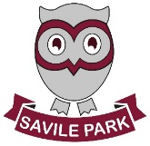
Summer 1
Learning in Year 2

South Africa
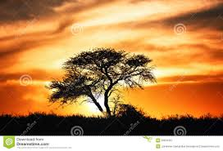

As scientists we will:
- Begin to learn about plants,
how they grow and what they
need to survive.
- Planting our own plants
- Experimenting on plants.

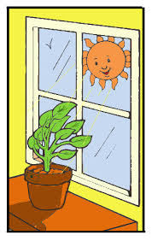
As mathematicians we will:
- Understanding and using fractions, including quarters, halves and thirds.
- Telling the time to 5-minute intervals.
- Continue to practice our 2x, 5x and 10x tables.
- Continue to use the four operations to solve problems.

As members of our community we will:
- In RE, looking at how different religions welcome new life.
- In PSHE, we will look at relationships with our families and friends.

As musicians we will:
- Learn about rhythm, pitch, scales and tempo through songs and instruments.
- We will listen to a variety of African and South African Music.

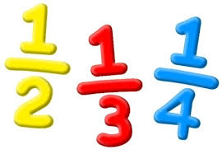

As Linguists we will:
- Continue to learn how to use capital letters, full stops, exclamation and question marks.
- Focus on apostrophes for possession.
- Continue to look at homophones and Year 2 common exception words in our spelling.
- In our spelling programme we will be looking at:
- Why does ‘c’ make the sound /s/ in some words?
- How can I spell the sound /zh/?
- What happens when I add the suffixes -ment, -ness, -ful -less and -ly to a root word?
- How can I show missing letters in a word?

As Geographers we will:
- Compare the physical and human features of South Africa and England.
- Use atlases, maps and the internet to find where the different continents are and label them on world maps.
- Look at the climate in South Africa and how this influence what animals live there.

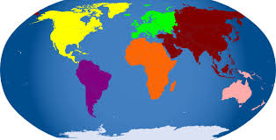

As designers we will:
- Working with clay and different tools to shape and manipulate clay in different ways.
- Creating clay house tiles.
- Be inspired by African designs.

