As Readers and authors we will be:

- Reading different stories, fairy tales and history about different Kings and Queens.
- Writing some fact files about kings and queens of the past.
- Comparing famous kings and queens including Henry VIII and King Charles III.
- Continuing to practice our phase 3 to phase 5 phonics sounds and tricky words.
- Practice reading a range of words in preparation for the phonics test in June.

Summer 1
Learning in Year 1
Topic: Kings and Queens

As scientists we will be:
- Identifying and describing the basic structure of a variety of common plants, including trees.
- Identifying and describing a variety of common wild and garden
plants including deciduous
and evergreen trees.
- Continuing to observe and
record the weather as it
becomes warmer.

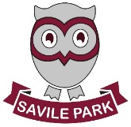

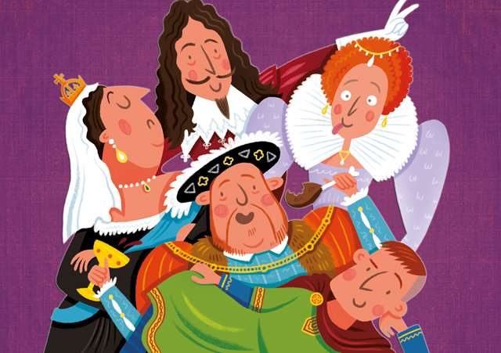
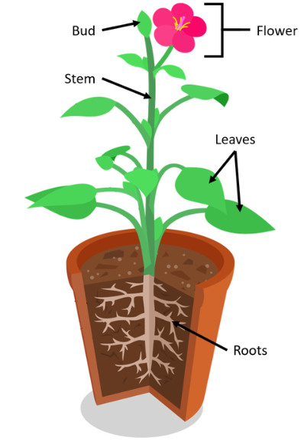

As design technicians we will be:
- Designing and making a healthy fruit juice or smoothie by choosing the right ingredients once we have learnt all about fruits and vegetables.

As linguists we will be:
- Reviewing all the phonemes, digraphs, trigraphs and their alternates from the phase 5 phonics scheme.

As mathematicians we will be:
- Counting, reading and writing numbers up to 100
- Counting in 2s, 5s and 10s to 100.
- Strengthening addition and subtraction skills
- Solving one-step problems involving multiplication and division with the use of objects, pictures and groups and teacher support
- Learning about fractions by halves of shapes and quantities then quarters of shapes and quantities.
- Describing position, direction and movement, including whole, half, quarter and three-quarter turns.

As musicians we will be:
- Having fun with improvisation. This will allow us to create music that belongs to us and be able to express our feelings and ideas. During this half term we will be listening to different genres of music, singing, playing, composing and improvising and finally, performing.

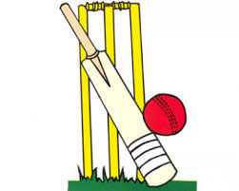
As athletes we will be:
- Focusing on our fundamental
movement skills, including
coordination and agility.
- Learning to play cricket.

As computing specialists we will be:
- Comparing the effects of adhering strictly to instructions to completing tasks without complete instructions.
- Following and creating simple instructions on the computer and considering how the order of instructions affects the result.
- Understanding the functionality of the direction keys, including additional direction keys.
- Understanding how to create and debug a set of instructions (algorithm).
- Creating a longer algorithm for an activity.
- Taking a look at an online Virtual tour of a castle.
As historians we will be:
- Learning about the lives of significant kings and queens.
- Comparing and contrasting the reign of famous kings and queens.
- Exploring aspects of everyday life for kings and queens of the past.
- Understanding the difference between the past and present life.
- Investigating why things happened and what happened as a result of historical events.

As members of the community we will be:
- Learning how to build positive, healthy relationships.
- Welcoming visitors linked with our topic and taking part in an active workshop.

