

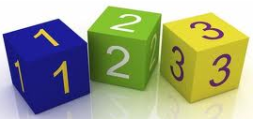
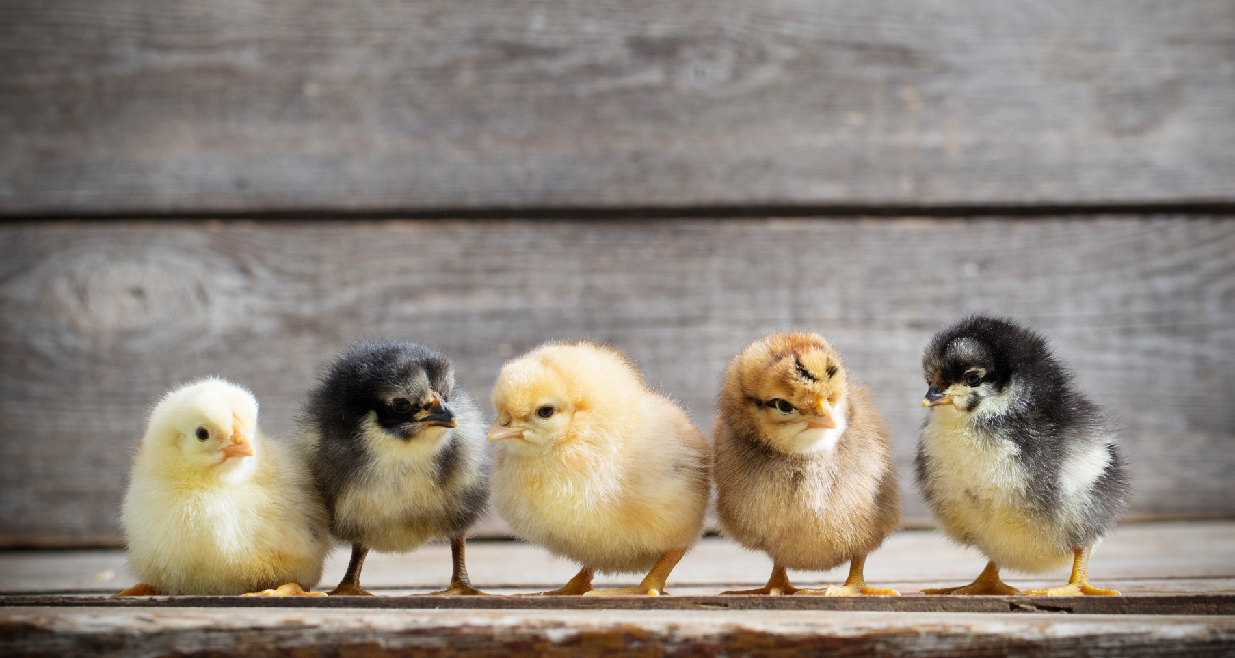

Reading books will changed on Friday each we
Homework Phonics will be sent out on a Friday, please return by the following Wednesday.

In Understanding the world we will:
- Look at how the baby animals grow and develop, including chicks.
- Look at the life cycles of caterpillars and tadpoles and how they develop into butterflies and frogs.
- Continue to observe the effects of changing seasons as we move into summer.

In Communication and Language we will:
- Be using topic books to retell stories to the class.
- Thinking about the stories we have read and build upon this through role play, developing their own narratives.
- Recalling events that have happened in our own life, focusing on turn taking.

In Maths we will:

- Practise counting beyond 20.
- Focus on the language of more than, less than and equal to when comparing numbers.
- Rehearse the order of numbers to 10 and have a good understanding of where the numbers belong in the sequence.
- Partition numbers to 7, seeing that 7 can be made up of a 5 and 2.
- Begin to think about doubles within 10.
- Sort and classify objects according to different criteria.
In Expressive Art and Design we will:

- Investigate different ways materials can be attached.
- Explore paint and painting techniques through nature, music and collaborative work.
- Develop creativity through child-led exploration of mixed media, making collages and art.
In Literacy we will:
- Consolidate our understanding of the digraphs and trigraphs and reading longer words and words with different endings.
- Begin to use digraphs in our writing.
- Writing captions and phrases, focusing on using finger spaces, a capital letter and a full stop.
- Answer questions about what we have read.
- Read a range of fiction and non fiction books.
In Physical Development we will:
- Explore sending and receiving using different sized balls.
- Perform a small range of skills and link two movements together.
- Perform a single skill or movement with some control.
- Move confidently in different ways.

In PSED we will:
- Think of ways to solve problems and stay friends.
- Begin to understand the impact of unkind words.
- Know how to be a good friend.
- Describe ourselves in positive ways and talking about what we are good at.
- Learn how to look after animals and keep them warm and safe.

Summer 1 Learning in Reception:
Terrific Transformations!

