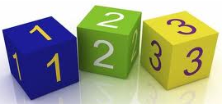

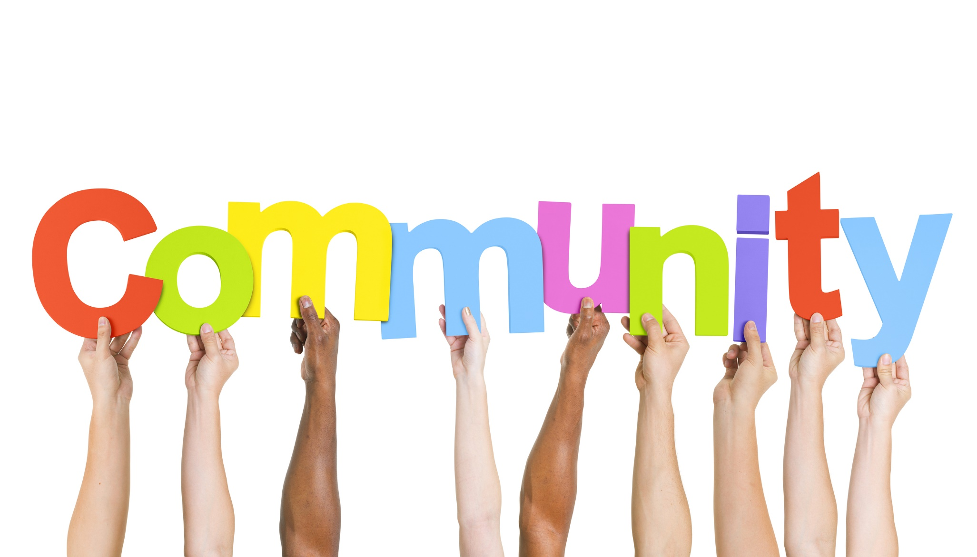
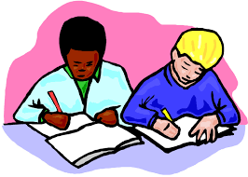
As designers we will be:
- planning, designing and creating our own space related product and
- using a range of different materials to help create a product for purpose.

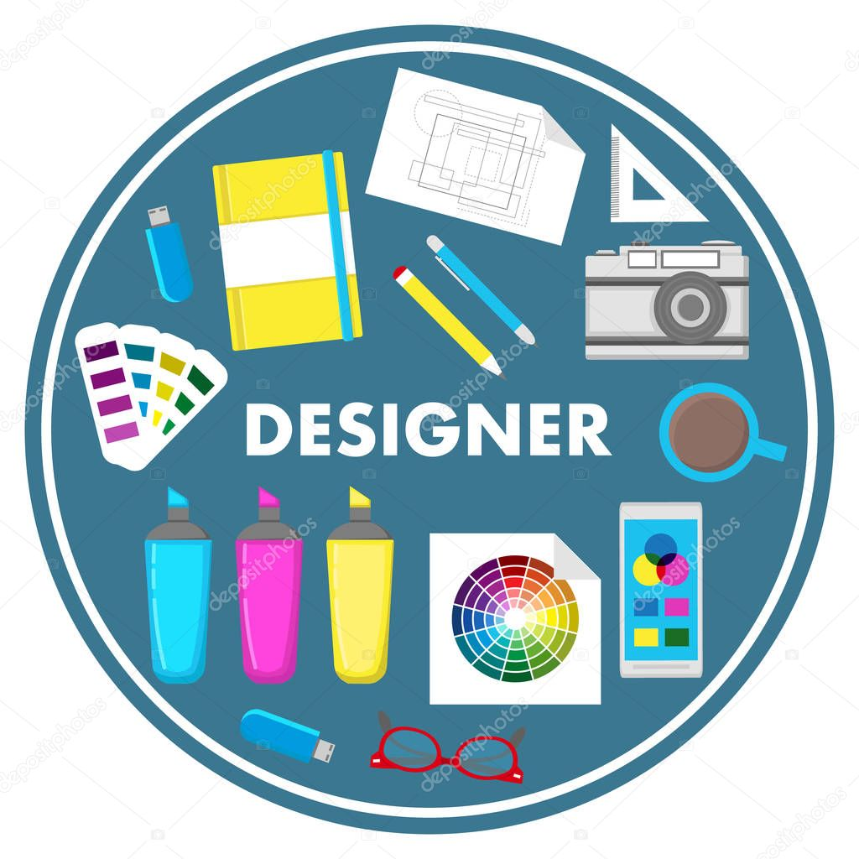
As historians we will be:
- studying the lives of famous people involved in space exploration!
- learning about the men of the Apollo space missions and
- looking at key events in the “space race” and the build up to the moon landing.
As members of our community we will be:

- Looking at how and why people pray.
- Children will look at how different religions pray

In PSHE children will setting dreams and goals.
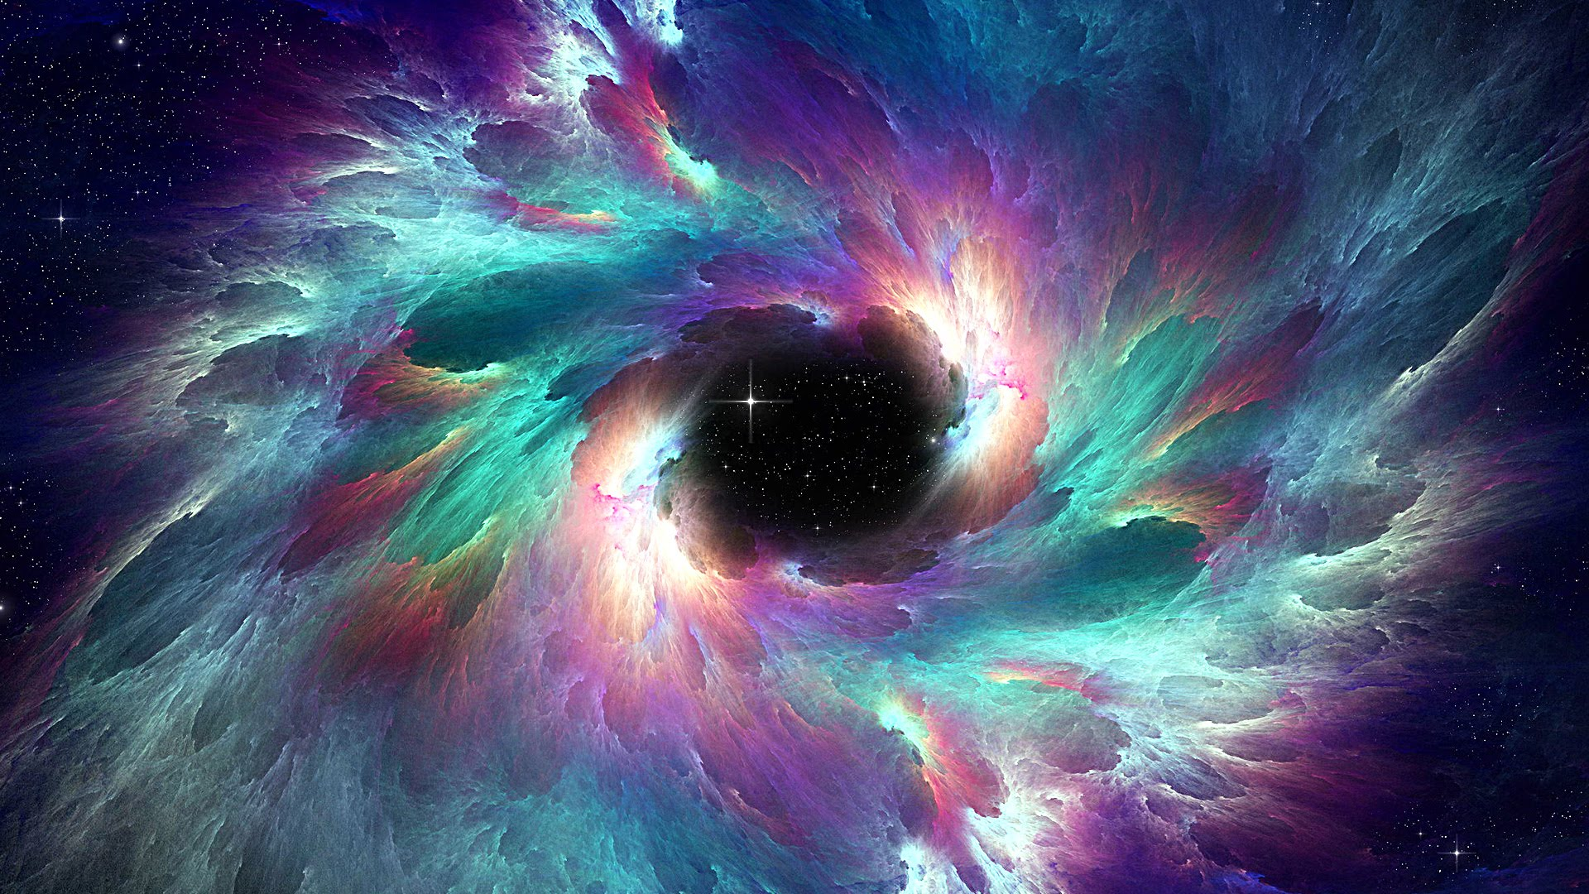
As linguists we will be:
- learning how and when to use a range of adjectives
- understanding how to use irregular past tenses whilst writing and
- learning how to use nouns and verbs
As mathematicians we will be:
- Counting money in pounds, pence and notes.
- Making different amounts of money.
- Calculating change and solving two step problems involving money.
- Using arrays and making groups to solve multiplication problems.
- Using our 2, 5 and 10 times table to multiply and divide.
As readers and authors we will be:
- reading a range of ‘space themed stories’ including “Bob, Man on the Moon”
- writing a report based on space and
- performing and writing poems based on space
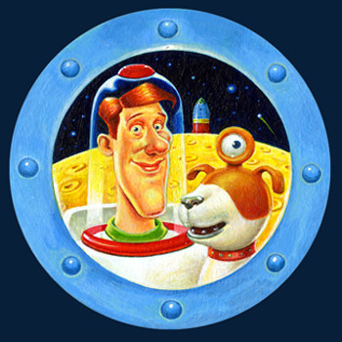
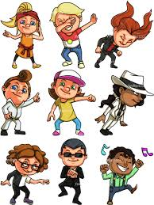
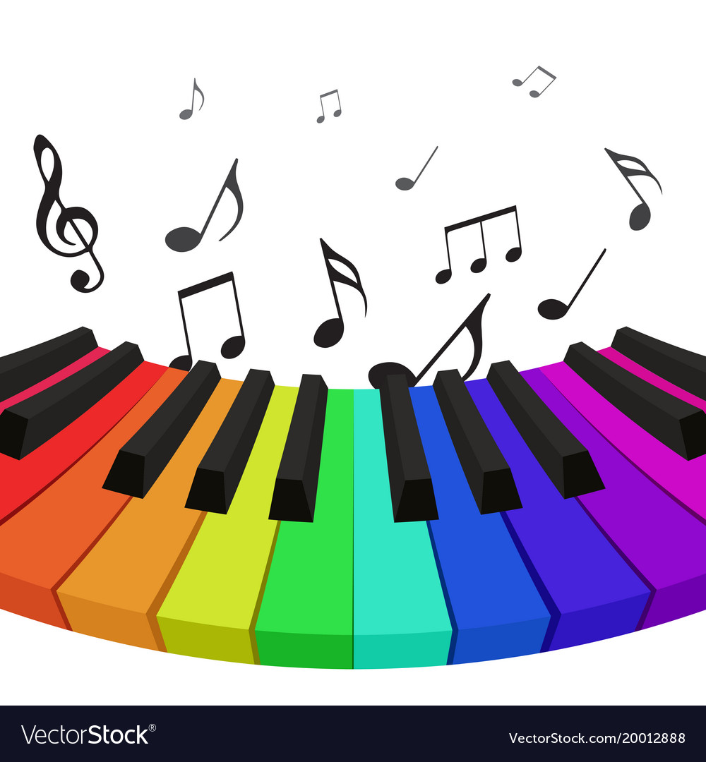
As musicians we will be:
- learning about rhythm, pitch, scales and tempo through songs and instruments
- listening to a variety of music by famous composers from classical to pop music

As scientists we will be:
- Learning about animals including humans.
- Life cycles and the stages of life.
- Healthy living and eating
- Hygiene
As athletes we will be:
- improving our fitness, co-ordination and balancing abilities and
- learning and taking part in
gymnastics routines
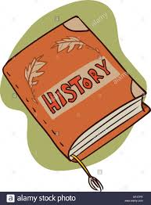
Savile Park Primary School
Spring 1
Learning in Year 2
Theme: Space

