As Readers and Authors we will be:
- Reading a variety of texts including those linked to our topic of The Romans.
- Looking at debates and comic book style stories
- using inverted commas to portray speech within our stories.
- Continuing to work on our text structure and organisation including writing paragraphs around a theme.
- Showing understanding of features of
different genres.
- Working on our grammar by using conjunctions to express time (before, after, as, when, since).

Savile Park Primary
Spring 1 Learning
in Year 4
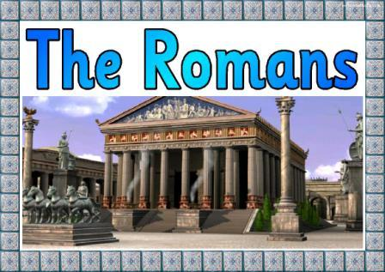

As Athletes we will be:
- Developing PE skills in a variety of ways including sending and receiving, counter balance with a partner, balance, strength and flexibility (gymnastics).
- We will be going swimming to develop essential skills.



As Mathematicians we will be:
- Looking multiplication and division in a formal written method.
- Learning about length and perimeter.
- We will also be looking at fractions.

As Scientists we will be:
Continuing to develop our knowledge of how vibrations cause sounds and how sounds travel. We will learn about how sounds are made, carrying out demonstrations of vibrations. We will explore pitch, make a string telephone, and will use this to investigate how sounds change over distance.
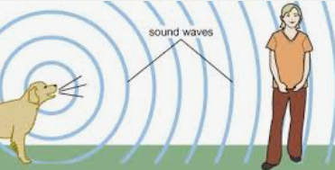

As Linguists we will be:
- Continuing to increase our French vocabulary and
- Learning how to use new phrases in different situations.
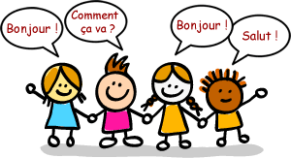

As Members of our Community we will be:
Looking at living in the wider world and how people can inspire us.

As Historians and Geographers we will be:
    - Learning about where the Roman Empire began.
    - Developing research skills to find out about Julius Caesar and what Roman Soldiers wore and why.
    - Looking at the Roman invasion of Britain.
    - Gaining a better chronological understanding of the Romans.

As Artists and Designers we will be:
- Developing ideas for 3D work through drawing and visualisation in 2D.
- Using more complex techniques to shape materials.
- Considering the effect of how sculpture is displayed.
- Choosing and joining a variety of materials to make sculptures.

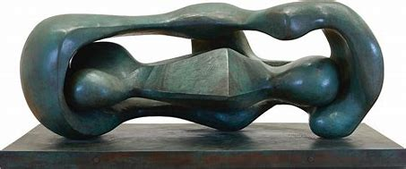

As Musicians we will be:
- Identifying, creating, notating and performing motifs.
- The theme of our motifs will be the Romans, linking it to our topic.


