As athletes we will be:
- Practising different ways to move and balance focusing on our core strength.
- Continuing to practice our throwing and catching skills.
- Incorporating these skills in the
games we play and a gymnastics unit.

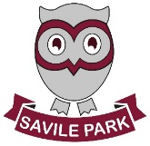
As readers and authors we will be:.
- Focusing our reading and writing around the story “An Egyptian Adventure”
- Encouraging children to think about paragraphing
- Using a range of openers, conjunctions and punctuation.
- Writing newspaper reports
about a famous discovery!

Savile Park Primary School
Spring 1
Learning in Year 3
Ancient Egypt

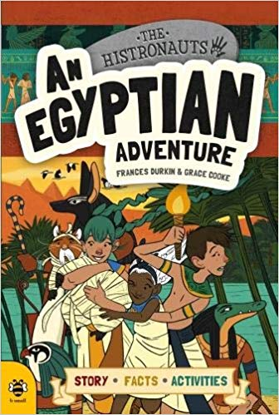
As scientists we will be:
- Exploring light and looking at how light is reflected from surfaces.
- Continuing to explore shadows.
- Investigating how shadows move and change size.

As mathematicians we will be:
- Continuing to practice the formal written methods.
- Continuing to practice our 3,4 and 8 times tables.
- Learn the grid method for multiplication.
- Solve multiplication and division word problems.
- Start to look at length and perimeter 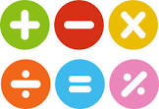

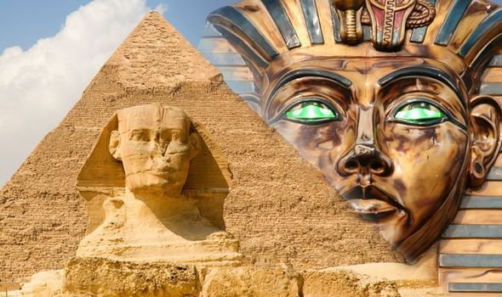

As musicians we will be:
- Identify the key features of a ballad.
- Perform a ballad using actions.
- Sing in time and in tune with a song and incorporate actions.
- Write a verse with rhyming words which tell part of a story.
- Perform lyrics fluently and with actions.



As linguists we will be:
- Continue to practice our French greetings and numbers.
- Begin to learn French colours and animals.
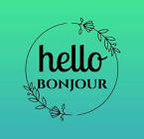

As members of our community we will be:
- Continuing to explore how different religious and non-religious groups express their spirituality through music, art and dance.
- Considering our own dreams and goals .
- 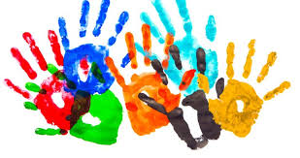

As Geographers and Historians we will be;
- Looking at where Ancient Egypt is in the world and researching the River Nile.
- Comparting and contrasting our lives and living conditions to what it was like then.
- Re-enacting some of the famous discoveries from Ancient Egypt.

